REQUEST FOR QUOTATION
- Procurement of Procurement of Hygiene/ IPC kits/ Dignity kits to girls

Request for quotation Nº: 03/ UNICEF- FAM-IRC from July 5th, 2023 |  | Procurement of Hygiene/ IPC kits/ Dignity kits to girls
Currency of quotation: |  | MDL
Price Quotation Form
Item | Product Name & Description |  | UOM | Unit Price, MDL | Number of Units | Total  (MDL)
I. Hygiene/ IPC kits
1 | Tooth Paste 125 gr/ tube  Each kit includes 1 pcs |  | tube |  | 56
2 | Hand Soap 250 gr/ bar  Each kit includes 1 pcs |  | bar |  | 56
3 | Tooth brush/ Soft and Medium mix  Each kit includes 1 pcs |  | pcs |  | 56
4 | Disinfectant spray 50ml  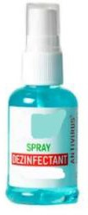  Each kit includes 1 pcs |  | pcs |  | 56
5 | Reusable masks  Each kit includes 3 pcs |  | pcs |  | 168
II. Dignity kits to girls
1 | Disinfectant spray 50ml |  | pcs |  | 1260

 | Each kit includes 1 pcs
2 | Soft Paper napkins  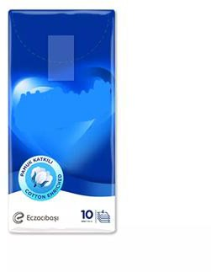  Each kit includes 1 pcs | pcs |  | 1260
3 | Wet Sanitary Wipes  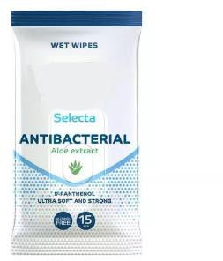  Each kit includes 1 pcs | pcs |  | 1260
4 | Women’s Sanitary pads (disposable)  /absorbante ciclu/:  Pack of 10, Disposable Menstrual Pads: Disposable /Content 10 pcs / pack/ Size: min 35 cm.  Each kit includes 1 pack | pack |  | 1260
5 | Specifications: cotton backpack, natural cotton fabric, at least 120 gr/m2, with  drawstring; size A4 (210 x 297 mm). Branded

with full color applied logos.

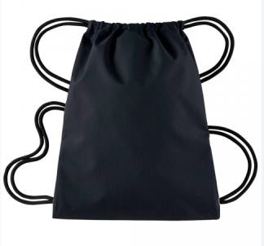
GRAND TOTAL

Partial quotations are not allowed under this RFQ.

The providers shall pack the above solicited products, according to the indicated quantities for each item.

Qualification Criteria:
- Full acceptance of the PO/Contract General Terms and Conditions
- Maximum delivery period not to exceed 25 calendar days.

Evaluation method:
- Lowest priced offer that is substantially responsive to the requirements of the RFQ.

Conditions for Release of Payment:
- Passing Inspection
- Written Acceptance of Goods based on full compliance with RFQ requirements.

Please submit your quotation in MDL currency, until August 4, 2023, to the following email address: ludmila.ivanov@fam.md

