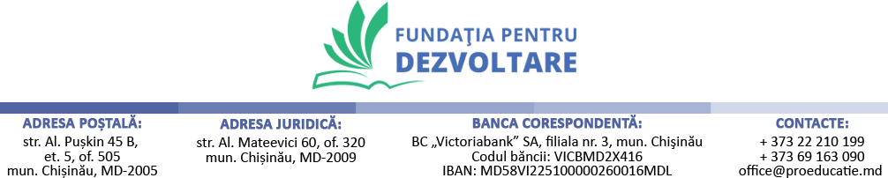

REQUEST FOR QUOTATION
Procurement of minor rehabilitation works
 | Request for quotation Nº: 05/ UNICEF- FAM-IRC from July 5th, 2023 |  | Procurement of services for minor rehabilitation works of safe and healing spaces in schools for children and youth involved in non-formal activities
 | Currency of quotation: |  | MDL
Price Quotation Form
Item |  | Product Name & Description |  | UOM | Unit Price, MDL | Number of Units | Total  (MDL)
Rehabilitation works
1 |  | PVC windows & doors (1200mm x 1800mm / 1200mm x 2100mm) & locket sets & installation service |  | m² |  | 50 m²
2 |  | Linoleum floor (3mm thick) & installation service |  | m² |  | 400 m²
3 |  | Lighting fixtures (6000k) & armstrong ceilings & installation service |  | m² |  | 350 m²
4 |  | Wall painting & surface finishing |  | m² |  | 400 m²
GRAND TOTAL

The quantity and volume of services may vary depending on actual measurements and needs.

Partial quotations are not allowed under this RFQ.

Qualification Criteria:
- Full acceptance of the General Terms and Conditions
- Maximum delivery period not to exceed 25 calendar days.
- Maximum service period not to exceed 45 calendar days

Evaluation method:
- Lowest priced offer that is substantially responsive to the requirements of the RFQ.

Conditions for Release of Payment:
- Passing Inspection
- Written Acceptance of Goods based on full compliance with RFQ requirements.

Please submit your quotation in MDL currency, until August 23, 2023, to the following email address: ludmila.ivanov@fam.md

