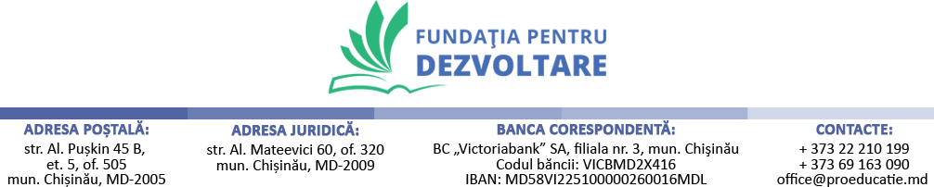
REQUEST FOR QUOTATION
- Procurement of equipment and furniture
 | Request for quotation Nº: 02/ UNICEF- FAM-IRC from July 5th, 2023 |  | Procurement of equipment and furniture
 | Currency of quotation: |  | MDL
Price Quotation Form
Item |  | Product Name & Description |  | UOM | Unit Price, MDL | Number of Units | Total  (MDL)
Furniture
1 |  | Furniture for safe spaces / communities (1 Black table, legs 1800x900 + 6 chairs) |  | Each |  | 15
GRAND TOTAL

Partial quotations are not allowed under this RFQ. Qualification Criteria:
- Full acceptance of the PO/Contract General Terms and Conditions
- Maximum delivery period not to exceed 25 calendar days.

Evaluation method:
- Lowest priced offer that is substantially responsive to the requirements of the RFQ.

Conditions for Release of Payment:
- Passing Inspection
- Written Acceptance of Goods based on full compliance with RFQ requirements.

Please submit your quotation in MDL currency, until August 4, 2023, to the following email address: ludmila.ivanov@fam.md

